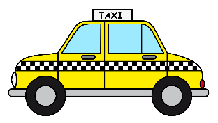
Did someone call for a TAXI?
Taxicab Geometry involved the distance between two points but is not measured by a straight line. It is measured by horizontal or vertical lines as if traveling on an actual road.

Below are questions that you must answer using the map provided to you.
- What is the distance from the closest grocery store to your school?

_________________________ blocks
- How many blocks is it from where you are to your house?

_________________________ blocks
- What is the distance from your school to the closest library?

_________________________ blocks
- How many blocks is it from the gas station to the local park?

_________________________ blocks
- What is the distance from your house to your school?

_________________________ blocks
- How many blocks is it from the park to the library?

_________________________ blocks

Can you figure out how many miles based on how many blocks you went in each question?

- _______________________ miles

- _______________________ miles
- _______________________ miles

- _______________________ miles
- _______________________ miles
- _______________________ miles

