Establishing a Professional Learning Community in SST 309:
Who I am, my strengths, and my preferences…
Whenever a group of people come together to learn, there is a chemistry they create. My goal for any class I teach is to help us all to work well together, to have fun learning, and to care about one another. As the teacher, it is up to me to create these conditions for success. Because the first step is familiarity, I ask for the following information. If there is anything you are uncomfortable about sharing, you have the option of leaving it blank.

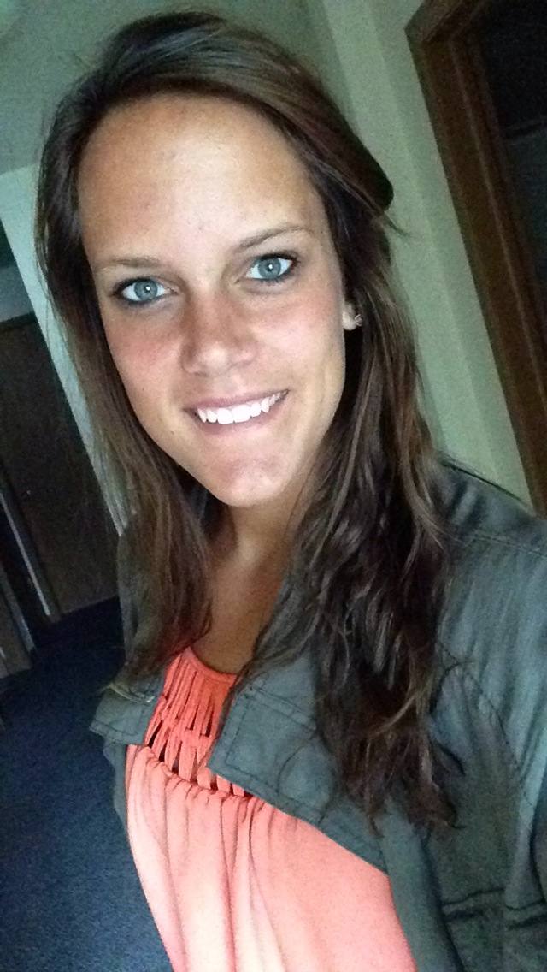
- My picture: (I DO need this for my own future records and to help me visually get to know you. Make it a picture in which your face is prominent.)
(shown to the right)->
- My name and what I like to be called:
My name is Kourtney Wolters. I don’t mind Kourtney but people call me Kourt.
- My home base: (state, city, family, etc.)
I was born and raised in Hudsonville, Michigan. I have five people in my family: a father, mother, twin sister, and a younger brother.
- My hobbies/outside interests/pets:
I love to spend my free days just hanging out with family and friends. My favorite hobby would be playing volleyball whether it’s indoor or out on the beach.
- My educational background: (high school, college, military, etc.)
I went to Unity Christian High School. Than choose to further my education by going Grand Rapids Community College for two years than I transferred to Western Michigan University for one year. Now I am in my first year at Grand Valley State University but overall this will be my fourth year of college.
- My outside responsibilities: (job [where], family [who], etc.)
When I’m not doing anything regarding schooling, I got the opportunity to play on the volleyball team here at Grand Valley this year.
- My major(s): (past, present)
I am majoring in Elementary Education: Math.
- Why I decided to become a teacher:
It all began when I went on a mission trip to an orphanage in Jamaica. The kids there cherished school, relationships, etc. While in Jamaica I got to help 2nd graders learn how to read. In that moments I knew that helping a child do such a small task was not only rewarding for them but it opened my eyes to the wonders the field of education/teaching can change people’s life.
- My occupational history/goals for education (country, state, city, district, grade level, content area[s]):
Once I graduate I would love to stay in West Michigan and teach grades ranging from Kindergarten to Third Grade. Although, I’m not opposed to going out of state but I’m a family person and could only do it for a couple years.

- My past experiences with Social Studies in K-12 have been
mostly positive
somewhat positive
neither positive nor negative
somewhat negative
mostly negative

- No matter how you answered number 10, what would have made the experiences better?
There were some teachers I had through Elementary/Middle school that I loved better than others. The reason I liked some better was because I learn the best with being hands on. I can’t retain information by someone just lecturing about a topic. I have to have a handout in front of me or an activity to do to help me understand.
- When I work with others, they can count on this from me:
I’m the type of person that likes to organize task and whatever anyone doesn’t want to do I am more than willing to do it. I would say people count on my willingness to help in any way I can.
- When I work with others, I like to be able to count on others to:
When doing group projects the one aspect that bugs me is when people are lazy with their work. They just go through the motions and get the basic understanding of it. I want to be able to count on my group mates that they will put the same effort I am going to into the project.
- I am a A. big picture or B. detail person. An example is:
I don’t think I can classify myself with either one of those options. It depends on the circumstance I’m in. For example, while going through college I am looking at the big picture of what all the classes and relationships will lead me to; however, every day I focus on the little details of how I can get myself there. If I had to choose one I’d be more detail oriented person.
- Whenever I take a class, my hopes (over and above the grade) are that…
Every time I start a new class I always look forward to learning something new. That sounds obvious but I don’t just mean information wise. I mean learning something I can take onto other classes and my future lifestyle; whether that’s in my classroom or my relationships with others.

