Answer Sheet for SST309 Students
(Handouts)

Answer Sheet for LOC Activities
Activity Number – (Do the Preparation activity, then choose 5 of the numbered activities. Do the Evaluation and the Reflection.) | Insert work electronically on this side:
Preparation – Education Extras – (all SST309 students will complete this one)  (4 titles – see right) | Early Elementary – Family Histories  by: Julie Castle & Marcy Goyett  Michigan – Underground Railroad in Michigan and The Great Lakes Region  by: Kristina Vanhala  5th grade – Revolutionary War: The Stamp Act of 1765  by: Maria E. Wallevard  Intermediate – History of the Star Spangled Banner(1783-1815)  by: Joanne Chouinard
First Activity | Activity One:  - In the center of the page under Collection Highlights are squares that take you into the collections. Click on American Memory. In the Search box at the top, type in Valley Forge. The first entry is “At Valley Forge.” Click on that and View the text, then Listen to the original speech (about 3 minutes). Write one sentence telling the gist of the speech and why it would be effective for 8th graders to both listen to and read the words of this speech.  The Valley Forge was where Washington and some other men starved and froze through the winter of 1777-1778, because our fortunes sank to its lowest point but from here it grew into what our world is today; which by listening too and hearing this speech will give students a sense that what seems like the most smallest battles created a big outcome in the end.
Second Activity | Activity Three: (related to 5-U2.3.2 Describe the daily life of people living in the New England, Middle, and Southern colonies.)  - From the home page of the LOC, www.loc.gov, click on the square called Prints and Photographs. Type in Colonial life in the search box. See #2, “Photocopies of original historical prints…colonial life.” Click on the Group of images. Based on these pictures, what do you see and what could you say about life in colonial America in three sentences?  In the 36 pictures of Colonial America a couple aspects stuck out. First, there were several pictures of a battle scene or destruction of places, or guns in the photo; which I would take as it was either a violent time or people, needed protecting. Finally, I noticed that when pictured the woman were always sitting or doing some kind of house work or elegant thing; whereas the men are standing tall with a gun or some sort of weapon proud.
Third Activity | Activity Four: (related to 4-G4.0.1 Use a case study or story about migration within or to the United States to identify push and pull factors [why they left, why they came] that influenced the migration. AND  4-H3.0.7 Use case studies or stories to describe the ideas and actions of individuals involved in the Underground RR in MI and in the Great Lakes region.)  - To the right of the squares, there is a section called “Especially for…” Click on Kids and Families, then the circle labeled Local Legacies. On the US map, click on the state of Michigan. On the list, click on Underground RR Activity in SW Michigan. Read the paragraph. On a map of Michigan, locate and label the MI locations (Detroit, North Berrien, Vandalia, Cass County) mentioned in the paragraph.  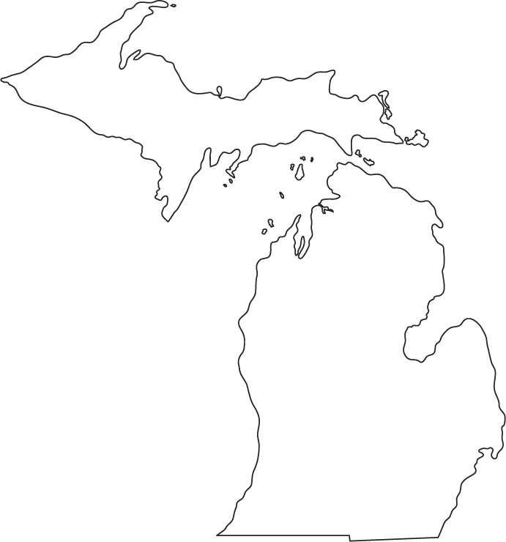  Vandalia <- Detroit  North Berrien-> <-Cass County
Fourth Activity | Activity Five: (This activity addresses the idea of chronology and that events have happened in the past. It could be used for building this concept with K-2 students, supporting the H2.0.1 GLCEs.)  - Scroll to the bottom of the Home page and find the Explore and Discover section. Click on Today in History, read about this day in history, then click on the word Archives. Type in your birthdate (month and date) under number 2. What 3 important things happened on your special day? What are the primary sources the museum has for each? If there are less than 3 events on your birthday, choose events from the day before or after.  On October 29 quilting began with a woman named Harriet Powers.  On November 29 Amos Bronson Alcott an educator, philosopher of American Transcendentalism, and father of the original "Little Women" was born in 1799. He also had two daughters and one of them, Louisa May Alcott, was also born on November 29, 1832. The day before the 29th is also significant because the First American Automobile Race took place from Chicago to Evanston, Illinois.
Fifth Activity | Activity Eight: Connected to K – C2.0.1 Identify our country’s flag as an important symbol of the United States, and 1 – C2.0.2 Identify important symbols of the United States of America (e.g., Statue of Liberty, Uncle Sam, White House, Bald Eagle).  - Go to Google and type in ‘Google Advanced Search.’ Type in (separately) each of the symbols of the United States: ‘Flag,’ ‘Statue of Liberty,’ ‘Uncle Sam,’ ‘White House,’ ‘Bald Eagle’ under “Find pages with these words:” then scroll down to “Then narrow your results by” and type in ‘loc.gov’ in the ‘site’ box. Choose one image for each symbol and copy and paste that image onto a table. Include the citation for each one.
Flag of U.S.: | 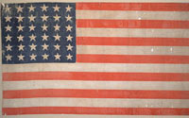 Thirty-Six Star United States Flag. 1865-67. Color woodcut on linen.
Statue of Liberty: | 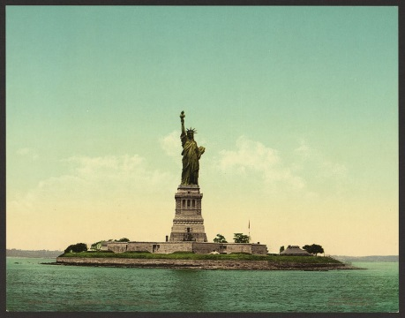  Statue of Liberty, New York Harbor. 1905. photomechanical print. Detroit Photographic Company.
Bald Eagle: | 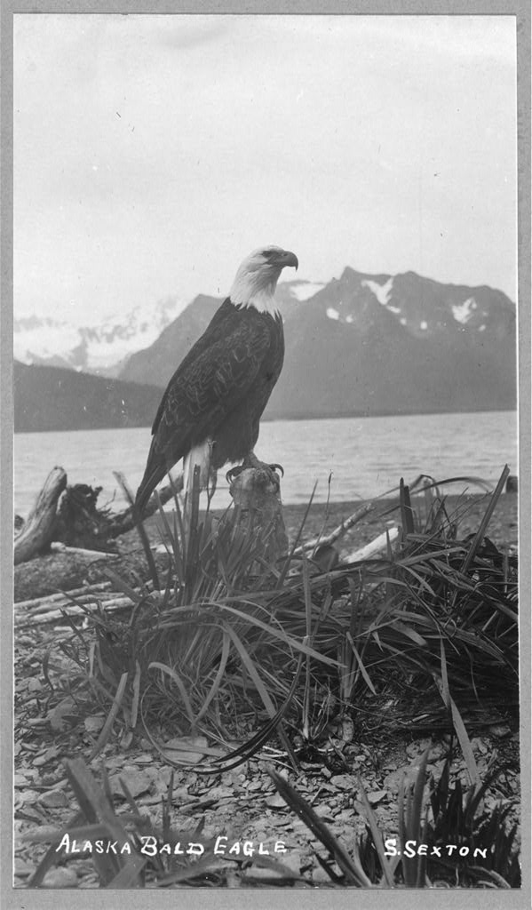  Sexton, S. Bald Eagle. 1990-30. photographic print.
Uncle Sam: | 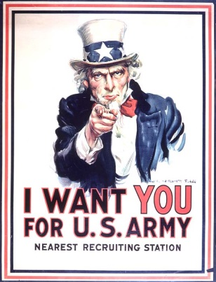  Flagg, James M. I Want You For The US Army. 1917. Litograph.
White House: | 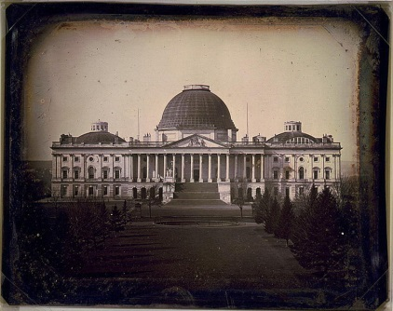 Plumbe, John. United States Capital: Washington D.C. 1846. Daguerreotype photo.
Evaluation Choice: A or B | B. Students in SST309 will go to the National Archives link:  http://www.archives.gov/education/lessons/worksheets/  and then use one of the analysis sheets to analyze a resource from the Library of Congress. They will have to show which Social Studies Grade Level Content Expectations that resource would support.  ANALYSIS: Photograph  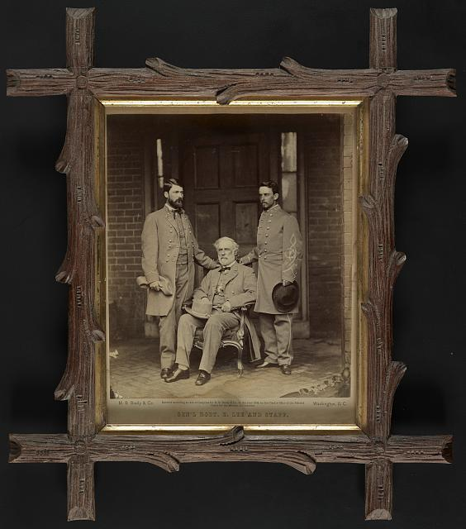  http://www.loc.gov/pictures/item/2011648617/resource/  (The analysis sheet that is used to analyze this picture is attached on the next page.)

Reflection –
- What is the most valuable take-away you have gained by learning about the resources at the Library of Congress?
Before doing this activity I’ve only ever knew that this was available. I’ve never checked in depth about it before. I realized that this is going to be a helpful site for information if I ever get stuck on a Social Studies unit. They have so much information and fact about what happened in the past.

2. What is the value of studying history using primary source documents?

Using primary source documents make History to me come alive. I learn more about the subject than I ever would if I just read a chapter on a unit. Artifacts and personal objects are a way to bring to life the unit at hand.

http://www.archives.gov/education/lessons/worksheets/photo_analysis_worksheet.pdf

