SST 309- Geo-Diary
Kourtney Wolters
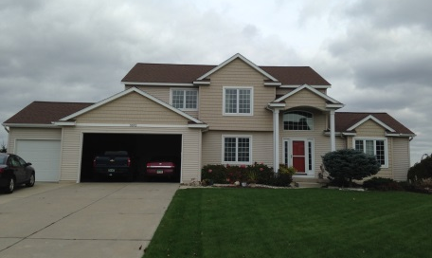
Hudsonville, MI- Home Base

1:44pm Sunday October 19 East
1. This is the place I like to call home. I’ve lived here for 11 years. It is located at 3372 Jamieson Drive in Hudsonville, Michigan. (Absolute Location)
The Motto
2:02PM October 19 East
2. The city of Hudsonville has a slogan: good people, good living. It is a small town. It would take you 15 minutes to get from one end to another. We even have a website to keep people aware of activities going on. (Human Environment Interaction: Human Impact)
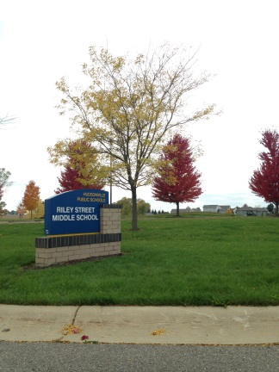
Where Kids Can Be Kids
1:49PM October 19 West
3. This is Riley Street Middle school. It is where most of my neighborhood can walk to school in the morning. It is located to the East of my house. (Relative Location)
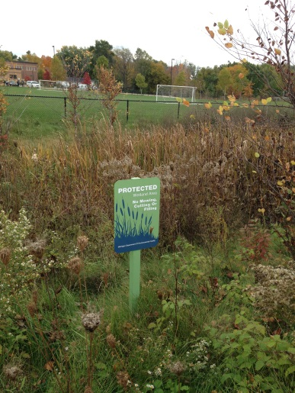
Nature at its Finest
1:47pm October 19 Southeast
4. This is a protected wetland behind my house that the Riley Street Middle school helps keep sheltered. (Place: Natural Characteristic)
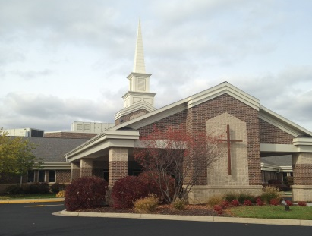
Spiritual Base

2:33pm October 19 North
5. Hudsonville Reformed Church is one of the 57 churches located in Hudsonville. Hudsonville offers a variety of places to worship and our active in supporting the community and congregation. (Place: Human & Cultural)
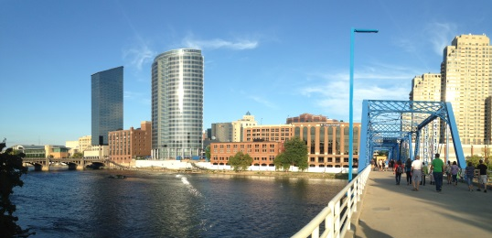
Our Big City
6:11pm September 28 East
6. This is part of the Grand River located in Grand Rapids, Michigan. Hudsonville is to the West of Grand Rapids. (Human Environment Interaction: Use of Resources)
Place of Learning
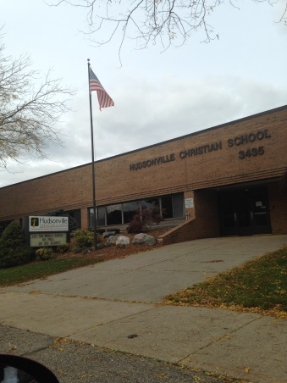
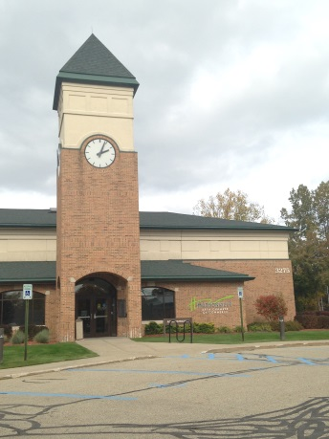
2:08pm October 19 Northwest
7. Hudsonville Christian Elementary School is grades Preschool through 5th Grade. It is approximately in the middle of Hudsonville. Kids come to learn in a friendly environment. (Human Environment Impact, Relative Location)
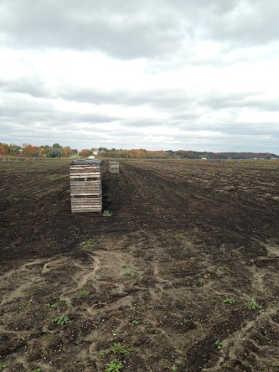
A Country Feel
1:56pm October 19 North
8. Onions and Celery are the produce that Hudsonville in known for. We have many farms that plant these crops. This farm is called CrispHeart (Region: Natural, Movement: Earth, Air, Water)
Town Meetings
2:03pm October 19 North
9. City Hall is where our fire station is located. If you have a problem with some issue involving Hudsonville you may go and voice your opinion. (Region: Human)
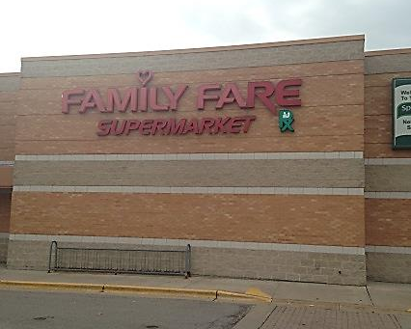
Need Food?

2:12pm October 19 West
10. Family Fare on Chicago Drive is where my family shops for groceries. It is a relatively small store and I know exactly what items are in each isle. (Movement: Goods & Services)
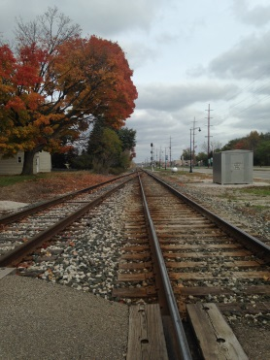
R & R
2:05pm October 19 West
11. We have a railroad track that breaks up our city. When asking where you live everyone asks: “What side of the tracks are you?” (Movement: People & Animals)
Where Knowledge is Found
2:06pm October 19 Southeast
12. Gary Byker Memorial Library is in the central of Hudsonville. It is the only library we have in our town. It is in honor of a beloved father, friend, man: Gary Byker. (Movement: Ideas & Information)
FUN FACT:
The famous Hudsonville Ice Cream was created by a family in Hudsonville: the Hoezee family. That’s how the ice cream got its name from our small town.

