Unit Plan
History: 1st Grade
H2-Living and Working Together in Families and Schools

Kourtney Wolters
SST 309-02
Susan Laninga
12.8.14

Table of Contents:
Grade Level Content Expectations ……………………………………………………………………….2
Overview/Rationale ...…………………………………………………………………………………………3
GLCE (1-H2.0.1) Lesson Plan…………………………………………………………………….……….…4
GLCE (1-H2.0.4) Lesson Plan ……………………………………………………………………………....7
GLCE (1-H2.0.5) Lesson Plan …………………………………………………………………………..…10
GLCE (1-H2.0.6) Lesson Plan ………………………………………………………………………..……13
Vocabulary Unit ………………………………………………………………………………………...………17
Handouts/ Worksheets:
Your Name Timeline (1-H2.0.1)..…………………………………………………………………..…….21
Example of Booklet (1-H2.0.4)……………………………………………………………………………22
A Blast from the Past (1-H2.0.5)…………………………………………………………………………24
Parent Slip for Family Pictures (1-H2.0.6)……………………………………..……………………25
Foldables Example (1-H2.0.6)……………………………………………………….……………………26

Grade Level Content Expectations:
First Grade History Unit (H2- Living and Working Together in Families and Schools)
- 1-H2.01: Demonstrate chronological thinking by distinguishing among past, present, and future using family or school events.
- 1-H2.0.4: Retell in sequence important ideas and details from stories about families or schools.
- 1-H2-0.5: Use historical records and artifacts (e.g. photos, diaries, oral histories, and videos) to draw possible conclusions about family or school life in the past.
- 1-H2.0.6: Compare life today with life in the past using the criteria of family, school, jobs, or communication.

Overview:
Based off of the Grade Level Content Expectations (GLCE) students must demonstrate, retell, use, and compare family or school life with chronological thinking by distinguishing among past, present, and future.
Rationale:
The reason students need to experience or learn this GLCE unit because it teaches you the basic’s about the difference between past, present, and future events by relating them to real-life. Starting students off small will help them grasp the content of the material being taught. Since this is in the history unit in first grade it also gets them more experienced with what has or will happen in the World. By exposing the students to something small when they are young will help them remember key events in life. This unit creates a fun way to learn about what History means by letting them figure out some topic they can relate to.

GLCE (1-H2.0.1)
KUD’s:
GLCE and Verb | (1-H2.0.1)Demonstrate chronological thinking by distinguishing among past, present, and future using family or school events.  LEARNING STYLE: Knowledge and Understanding
Knowledge (K) | Understand (U) | DOL:  Demonstration of Learning (DO) | Vocabulary | I Can
Chronological thinking is when you need to place certain ideas in order. In our case it will be based on what happened earlier (past), what is happening now (present), and what could/would likely happen further on (future). The best way people do this is by creating a timeline, which is a graph that places specific events in order based on when they happened. Your family history can help you with when special events happened and same goes with events that have happened in your school. | Students will understand that family or school events that have happened or will happen in the future tend to create a certain order. | The student will create a timeline based on theirs, yours, or other families past, present, and future plans. | Chronological  Timelines  Past  Present  Future  Events  Family  School | I can distinguish certain events based on when they happened.

4. Sequence of Instruction (including one below for Vocabulary): What will you do? What will they do?
Lessons: How will you take them where they need to go? (Step-by-Step plan)  Instructional strategies/Social constructs: How will they work?  (AND what will YOU do?) | Resources needed: What materials and resources will they need?  (Page #s read, graphic organizers, books, posters, realia, etc…)
Lessons: How will you take them where they need to go?  Anticipatory Set: (Hook)  “Who knows what’s going to in the future? [Wait for student responses]. Who knows what they did yesterday? [Wait for student responses]. What are we currently doing at this moment? [Wait for student responses].”  Modeling:  “Today class we are going to be learning about our past, our present, and our future plans. When I say go, I would like you to talk to the person next to you what you did over the summer. [Student’s communicate with each other]. This is an example of something that is described as a past event. Now talk to you partner again but this time about what you will be doing over Christmas Break. [Student’s communicate with each other]. This is an example of something that is described as a future event. Lastly, let’s talk about what you plan on doing right at this very moment. [Student’s communicate with each other].”  “Now that you all know the difference between past, present, and future I am handing out a piece of paper and on that paper there are five questions I want you to answer about yourself. These questions should have dates with them. There is a black straight line on the bottom of the paper. Once you are done answering the questions above place what you think event has happened in the past, present, or future.”  Check for Understanding:  “If you have any questions throughout the worksheet make sure to raise your hand high and tall. Before we begin I want you to tell your partner what you should be doing in the next 10 minutes.”[Student’s talked about activity].  Guided Practice:  [Walk around the room, helping students]. While walking around the room, observe how different children are categorizing these answers on the timeline.  Independent Practice:  Each student is given their own activity sheet to work on. They will have to hand it in once they are done. Once they are done you will hand them the exact same activity sheet again but blank and tell them to wait for further instruction. However, in the meantime tell the students that get done first to read a book from the book corner.  Instructional strategies/Social constructs: How will they work?  - Independently filing out the worksheet attached. | Resources needed: What materials and resources will they need ? (also included on Works Cited page)  - Worksheets  - Paper/Pencil/markers  - Any materials and resources from your ILA work: music poetry, primary sources, simulations, games, etc.
5. Assessment ideas: a. How will you know they’ve learned it? (Summative – Students demonstrate their learning.)
Students are handed a worksheet that have questions on it that they must answer and then transfer them into the timeline at the bottom of that worksheet.
b. How will you grade it?
They will be handing it in to the teacher (me) and I will look over them to make sure they got the dates and activities in appropriate order.

GLCE (1-H2.0.4)
KUD’s:
GLCE and Verb | (1-H2.0.4)Retell in sequence important ideas and details from stories about families or schools.  LEARNING STYLE: Skill and Performance
Knowledge (K) | Understand (U) | DOL:  Demonstration of Learning (DO) | Vocabulary | I Can
In order to retell something you must know all of the facts from a story. In our example we can look at a person’s family or life. By focusing on date of birth, elementary school, middle school, high school, college they went too, first house they bought, if married, kids, job(s), if retired, if/when passed away, etc.  There are also school events that a student can focus on to grasp this concept. Such as, knowing when it first started, where it started, who created it, rebuilding or add-ons, programs offered, etc. In the end you will be able to place in order (sequence) based on important details and the time it took place. | Students will understand that details from stories can be important when trying to place them in order. | The student will create a book in order based on important details that their families have experienced. | Sequence  Family  School  Events | I can talk to a person about family or school stories in order of when they happened.

4. Sequence of Instruction (including one below for Vocabulary): What will you do? What will they do?
Lessons: How will you take them where they need to go? (Step-by-Step plan)  Instructional strategies/Social constructs: How will they work?  (AND what will YOU do?) | Resources needed: What materials and resources will they need?  (Page #s read, graphic organizers, books, posters, realia, etc…)
Lessons: How will you take them where they need to go?  Anticipatory Set (the hook):  “Has anyone ever read a book about a person’s life before? What are the different characteristics they have talked about?” [wait for student responses].  “Today we will be creating our own booklet to frame a timeline of each of your lives.”  Modeling:  [Hold up a blank booklet to the class] “Class I have handed each one of you a booklet. Inside it there are blank pages with one sentence on each that you must answer.” [Hold up the model you created about your life]  “On the first page write your name and draw a picture of your family. Once you are finished with that begin by answering the other questions in the booklet and drawing pictures. You may notice these questions are similar to the ones I asked in the previous worksheet where you had to make a timeline. If you have any questions raise your hand and I’ll come to you.”  Guided Practice/Independent Practice:  [Teacher walks around helping and making sure students are answering the questions correctly]  Checking for Understanding (Formative Assessment):  “Students now that you have created your own personal story I want you to turn to your elbow partner and retell them from your book about your families.”  [Walk around the room and listen to students telling about their booklet].  Instructional strategies/Social constructs: How will they work?  - Cooperative activity; Collaborative work  - Group work  - Independent | Resources needed: What materials and resources will they need ? (also included on Works Cited page)  - Realia, Technology, Worksheets  - Paper/Pencil/markers
5. Assessment ideas: a. How will you know they’ve learned it? (Summative – Students demonstrate their learning.)
The will create a booklet based on the question asked in the Timeline activity worksheet. They will have to be able to tell the story to another person.
b. How will you grade it?
This activity is more based on participation not necessarily for a grade or something.

GLCE and Verb | (1-H2.0.5)Use historical records and artifacts (e.g. photos, diaries, oral histories, and videos) to draw possible conclusions about family or school life in the past.  LEARNING STYLE: Product
Knowledge (K) | Understand (U) | DOL:  Demonstration of Learning (DO) | Vocabulary | I Can
The best way to draw conclusions about a family or social life from the past is to look at different artifacts. Such as, pictures showing what people are wearing or living in. Diaries or writings people kept about certain events they had to go through. Oral histories, which are just talks between two people based on an event. Finally, videos may be helpful to place them in the environment that people went through in the past. | Students will understand how family and school life in the past has changed using multiple historical documents. | The student will be given a worksheet with different type of artifacts printed on it and then circle what they notice are different about families or schools in the past than today. | Records  Artifacts  Photos  Diaries  Oral Histories  Videos  Past | I can make conclusions about family and school life based on different documents from the past.

4. Sequence of Instruction (including one below for Vocabulary): What will you do? What will they do?
Lessons: How will you take them where they need to go? (Step-by-Step plan)  Instructional strategies/Social constructs: How will they work?  (AND what will YOU do?) | Resources needed: What materials and resources will they need?  (Page #s read, graphic organizers, books, posters, realia, etc…)
Lessons: How will you take them where they need to go?  Anticipatory Set: (Hook)  “Today students we will be taking a trip to the past. The past is what has previously happened. Can anyone tell me an event they did this past weekend?” [Pick two-three students to respond].  Modeling:  “I am handing out a worksheet that has a couple pictures on it. I have brought some real life artifacts from my house.” [Show the three different objects: clothing, books, & phone]. Describe why these pieces are from the past to the students.  “I want you now to look at the pictures on this worksheet and circle objects or anything you notice that you’ve either never seen before or an object has changed from back then to now. Then follow the directions from there. If you have any questions remember to raise your hand and I’ll come to you. Once you are done please set your pencil down.”  Guided Practice:  This is when the teacher (you) will show the three artifacts from the past.  Independent Practice:  Students are to work on the worksheet individually.  Check for Understanding:  “Alright classes, since I notice most of you are done with the worksheet we will now go over it.” [Go picture by picture asking students what they thought of the picture and what they think it is].  **side-note: pick students from the tongue depressor jar that way each student has a chance to give their input on a picture.  Instructional strategies/Social constructs: How will they work?  - Reallya-Making Thinking Visible  - Independent | Resources needed: What materials and resources will they need ? (also included on Works Cited page)  - Web site(s)  - Realia, Technology, Worksheets  - Paper/Pencil  - Little Kid Family Tree Video
5. Assessment ideas: a. How will you know they’ve learned it? (Summative – Students demonstrate their learning.)
By asking students to tell me what they noticed in the picture on the worksheet and telling me why it represents the past, will tell me that they can draw conclusions based on historical records or artifacts to make connections about families then and now.
b. How will you grade it?
As long as every student says one thing they notice in the pictures and why they think that represent the past then they get an “A”. Not a really grading activity, more of a gold star on their worksheet when they hand it in.

GLCE (1-H2.0.6)
KUD’s:
GLCE and Verb | (1-H2.0.6)Compare life today with life in the past using the criteria of family, school, jobs, or communication.  LEARNING STYLE: Reasoning and Thinking
Knowledge (K) | Understand (U) | DOL:  Demonstration of Learning (DO) | Vocabulary | I Can
Learning to relate the past to present day, there are ideas to focus that have changed throughout the years. One of them is the schooling and what people learned back then. For instance, programs that were geared more towards what is known as vocational education. Where students are taught skills in order to perform a specific job. Where as in the present day we focus on a variety of different subjects: Math, Science, English, History, Physical Education, Art, Music, etc. Another change is what jobs people had back then. For example, the typical jobs were: Milkman, Typists, Switchboard Operators, Iceman, Elevator Operator, etc. Whereas now you see that we have progressed in the communication or resources available that we no longer need those jobs. Such as, computers, refrigerators, telephones, etc.  Even family life has changed since the past. For example, women and men both are able to have an actual job. Instead in the past women were known for being only designated to household duties, such as, cleaning, cooking, raising children, etc. | Students will understand that people who lived in the past compares to how life is in present day. | The student will be given different pictures and they will need to be sorted by school, jobs, family, and communication and then sorted by past, present, and future by gluing them on a piece of paper. | Past  Criteria  Family  School  Job  Communication  Life  Compare  Vocational Education | I can tell how life today has changed since people lived in the past.

4. Sequence of Instruction (including one below for Vocabulary): What will you do? What will they do?
Lessons: How will you take them where they need to go? (Step-by-Step plan)  Instructional strategies/Social constructs: How will they work?  (AND what will YOU do?) | Resources needed: What materials and resources will they need?  (Page #s read, graphic organizers, books, posters, realia, etc…)
Lessons: How will you take them where they need to go?  Anticipatory Set:  **(Don’t need to introduce this activity with a hook)  Modeling:  “Students we have been discussing the difference from the past and present for the past couple days. We are now going to be relating the past more visually by using different objects from your past and present. I have sent home earlier this week a parent slip stating that I need a picture of when you were young and a picture of you now. That is what is in the plastic baggies on your desk. Don’t open them until I explain what we are doing.”  [Hold up your own personal foldable]  “Students as you can see I have a paper here with two columns. One is labeled past and the either present. In the past section I have found pictures from magazines that represent the past. I have also found pictures that represent the present from magazine pictures as well. I also wrote under each picture what it is because that way I know why it fits in that column. You all are going to be creating one of these just like mine. I have printed off a variety of different pictures that you can use. You will use your glue stick to glue them onto the correct section the picture belongs in. The past and present picture will be up on this table but I will be calling table that are very quiet to come and pick out three pictures from the past and the present.” [Look and listen for the quietest table and choose them. Keep choosing until every table has gone. As you are choosing tables hand out the big paper with two columns: past and present].  “Alright class you may begin gluing the pictures on in the correct column on your paper. I will be walking around asking you why you put those pictures in the spot you did. If you have any questions raise your hand and I will come to you.”  Check for Understanding:  “Class once you are done please put your glue sticks back and place your papers on my desk so I can take a look at the pictures you have created. Once you have done this head to the reading carpet.”  Guided Practice:  [Teacher is walking around asking question about the students choices based on where they put the picture from the past or the present].  Independent Practice:  [Students choose any three pictures from each past and present idea and have to be able to glue them in the right column that is appropriate for that picture].  Instructional strategies/Social constructs: How will they work?  - Cooperative activity; Collaborative work  - Graphic organizers: Foldables  - Independent | Resources needed: What materials and resources will they need ? (also included on Works Cited page)  - Magazine picture of the past and present  - Worksheets  - Paper/Pencil/markers/glue sticks.  - Any materials and resources from your ILA work: music poetry, primary sources, simulations, games, etc.
5. Assessment ideas: a. How will you know they’ve learned it? (Summative – Students demonstrate their learning.)
Individual project created in form of a foldable and as the teacher goes around asking each student why he or she choose a certain picture to be placed where they did.
b. How will you grade it?
The students will be handing the foldable into me and I will then look at it to make each picture represents something that is either in the past or the present. I will not be putting a letter grade on this, I will put a sticker on it if they understood the point.

Vocabulary:
- Past, Present, Future
  - Description: Teacher will ask students questions about what happened in their life previously, what is happening now, and what will happen in the future. When they were born? What they did over the summer? What did you eat for breakfast today? What are you currently wearing? What do you want to be when you grow up?
  - Restate: The students will be write down in their Vocabulary Journal what they think, based off the questions asked by the teacher, the words mean to them.
  - Non-linguistic Representation: Play Flash cards with pictures of things from the past, present and future.
  - Activity: Create a worksheet with objects that represent past, present, or future things and have students tell whether they are past, present, or future.
  - Student Discussion: Student’s will compare their answers with their classmates that are sitting around them.
  - Games: Students have to opportunity to create a skit they think will best describe an event that has either happened, is happening, or will happen (past, present, future).
- Chronological Order
  - Description: Teacher will read the book “Me and My Family Tree” by Joan Sweeny to the class and then will ask them what order the little girl went in to create her family tree.
  - Restate: The teacher will call on certain students to give the next event that happened in the book according to the order the girl discussed.
  - Non-linguistic Representation: The students will have to write down in order based on when certain events happened in their life in the activity of the six questions and creation of their personal booklet.
  - Activity: students will try to think of other words that represent the same meaning as chronological order. (e.g. sequence, events happened)
  - Game: Students can grab the bag of pictures from events that has happened in our history and place them in order.
- Artifacts
  - Description: Bring in real-life objects that people don’t normally see on a day to day basis.
  - Restate: Have students write down their predictions as to what they think the objects are.
  - Non-linguistic Representation: Have students think of some object in their house that they think other people don’t have.
  - Activity: Have student point out artifacts that are in your classroom.
  - Student Discussion: Have students go home and look for an artifact that represents them to show in class the next day.
  - Game: Have students become a detective of a certain object and have them research about it and tell the class about that artifact and why it is important.

- Timeline
  - Description: Tell a story about a normal day in the life of a dog (or if you wanted to integrate multiple subjects such as science you could do and organism).
  - Restate: Have students tell you why it is important that you know exactly what the dog did in order on that certain day.
  - Non-linguistic Representation: Have students draw a picture of what they believe a timeline might look like.
  - Activity: Have students create a hypothetical story about something and place the events on a timeline format.
  - Student Discussion: Describe their hypothetical stories to a partner and see if they can get the sequence right.
  - Game: http://teacher.scholastic.com/activities/flight/timeline.htm Depending on the subject being taught about timelines they could go to an interactive website that lets you click on a date and see what happened then.
- History
  - Description: Show a video about an event (such as, family tree, founding of the United States, etc).
  - Restate: Have students write down what they notice in the film.
  - Non-linguistic Representation: Have the students create a picture of what history is to them.
  - Activity: Use the word family technique and discuss different aspect in history (such as history is in the past).
  - Student Discussion: Have students tell a story about their favorite summer memory.
  - Game: http://www.learninggamesforkids.com/social_women_in_history.html And interactive site that allows your students to choice a topic and they can learn about how to either spell them, match them up with a picture, etc.

(Place Your Name in blank below)
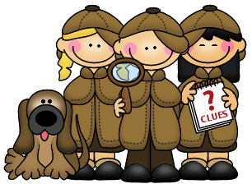
______________________________________ TIMELINE
Please answer the questions below about yourself.
- What is your birthday? ________________________________________________________
- Are you the oldest of your brothers or sisters? YES or NO
- How old are your brothers or sisters? __________________________________________________________________________________
- What are you going to do at recess today? ______________________________________________________________________________________________________________________________________________________________________
- What do you want to be when you grow up? ______________________________________________________________________________________________________________________________________________________________________
- What activities are you going to do over Christmas break? _________________________________________________________________________________________________________________________________________________________________________________________________________________________________________________________
Place your answers from above on the timeline below, based on when they will happen or have happened.

EXAMPLE BOOKLET:

Birthday:
November 29, 1992

Siblings Birthdays:
August 8, 1996

Sister is 21 years old

Brother is 18 years old

At recess: I will swing
on the swings with my friends.

On Christmas Break:
I will build a snowman.

What do you want to
be when you grow up?
I want to be a Doctor.

A Blast from the Past
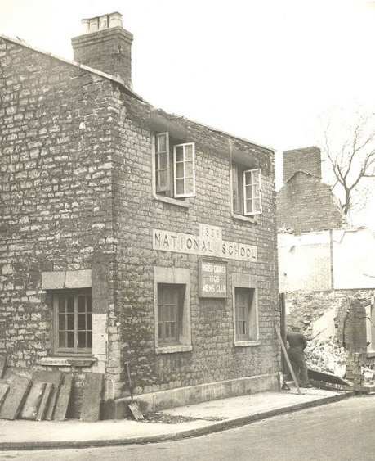
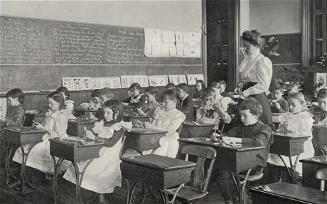
Circle different aspect in the pictures that you can tell this picture is from the past. Then write in the blanks below what the pictures are of.

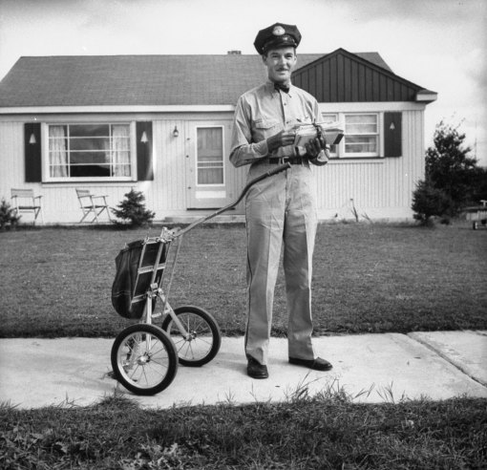
___________________________________________

_____________________________________
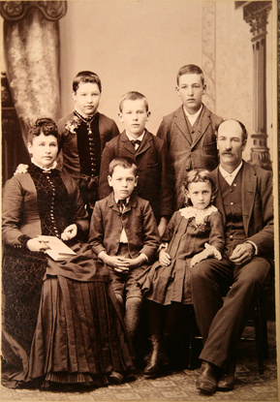

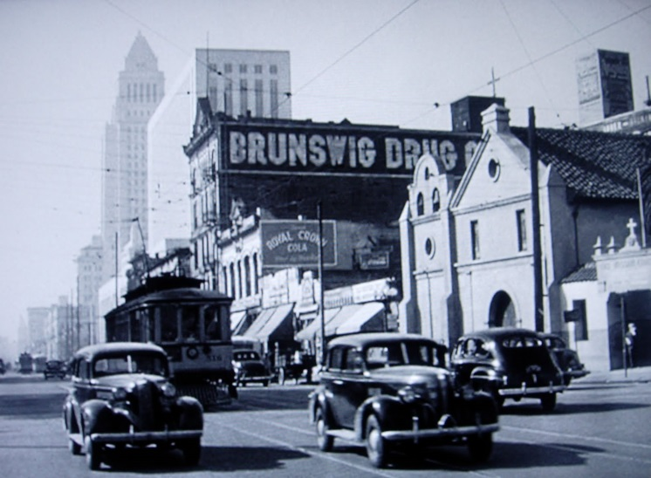
_______________________________________________

_______________________________________________ ____________________________________
1st Grade History Detectives
Dear Parent/Guardian,
In Social Studies, we are investigating ways that people learn about the past. One of the ways we learn about the past is through photographs. Photographs can provide evidence about family history.
As we explore our family histories, it would be very helpful if you could send in two photographs:
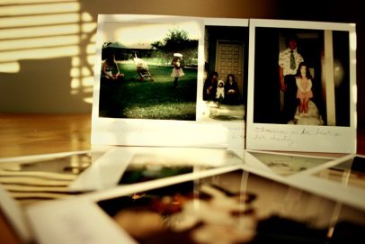
1. A photography including a picture of your child from the past (Can be a family picture or a baby picture preferably).
2. A recent picture of your child now (school picture is fine).
Please include the following information with the photograph:
- Who is in the photograph (If the picture is more than just your son or daughter).
- Where the photograph was taken
- The approximate date of the photograph was taken
- Any interesting details about the person/people in the
photograph

We will be sharing and displaying the photographs with the class and will also be looking for evidence or clues that the photographs were taken in the past and are now a part of our family history.
Thank you for your help with our Social Studies project!
Sincerely,

